Use Case Specification

DMT/RM01/TMP

|  |  |
| --- | --- |
| Project Code | PRJ_HotelManagement_001 |
| Project Name | Hotel Management |

|  |  |  |
| --- | --- | --- |
| Prepared/Modified by | Role | Date of Preparation |
| Harshita Ahuja | Test Engineer | 20/10/2018 |
| Reviewed by | Role | Date of Review |
| Himanshu,Ijas,Kartik | SME |  |
| Approved by | Role | Date of Approval |
| Christy | Test Manager |  |
| Circulation List |  | Version Number of the template: |
| Version Number | 1 |  |

<<Customer>> REVIEW HISTORY

<<Customer comments on the Use case along with the signed off is tracked here>>

|  |  |  |  |  |  |  |
| --- | --- | --- | --- | --- | --- | --- |
| Version | <<Version number>> |  |  |  |  |  |
| Date | <<Date of Review>> |  |  |  |  |  |
| Reviewed by | << Reviewer Name>> |  |  |  |  |  |
| Reviewed UI Specification doc | << Whether UI Specification doc is reviewed >> |  |  |  |  |  |
| All Open Queries/issues closed | << Whether all the open queries and issues resolved>> |  |  |  |  |  |
| Agreement on Assumptions | <<Whether all the assumptions have been agreed upon by the customer>> |  |  |  |  |  |
| Sign Off | <<Signature>> |  |  |  |  |  |

Disclaimer:

The scope of the project ‘<<Project Name>>’ is restricted to the contents of this signed off use case.

**TABLE OF CONTENTS**

1. Use case Name 4
2. Actor(s) 4
3. Preconditions 4
4. Flow of events 4
   1. Basic Flow 4
   2. Alternate Flow 1 5
   3. Alternative Flow 2 5
5. Exception Flow
   1. Exception Flow 1 6
   2. Exception Flow 2 6
   3. Exception Flow 3 6
   4. Exception Flow 4 7
6. Post Conditions 7
7. Special Requirements
   1. Availability 8
   2. Business Rules 8
8. Diagrams
   1. Use Case Diagram
      1. For Successful Adding of Hotel 9
9. Scenarios
   1. Success Scenarios 10
   2. Failure Scenarios 10
10. Issues 10
11. UI Specifications 11
12. Assumptions 11
13. Revision History of the work product 12

Use Case Name: Hotel Management system

**Use Case ID:**HotelManagement1.0

**Brief Description:**This usecase describes about the adding of the new hotel by the admin.

2. Actor(s)

1. Admin

2. Hotel Management System

3.Preconditions

1. The admin has successfully login into the site <http://ndafile:8081/Spring_Hotel/login.html>.

4. Flow of Events

4.1 Basic Flow

**Name: Sucessfully Adding of New Hotel**

1. Admin enters Hotel city.
2. Admin enters Hotel name.
3. Admin enters Address.
4. Admin enters description.
5. Admin enters average fare per night.
6. Admin enters Phone Number1.
7. Admin enters Phone Number2.
8. Admin selects Rating.
9. Admin enters Email.
10. Admin enters Fax.
11. Admin clicks on Add Hotel button.
12. System displays the message “Hotel added successfully”.

Alternative Flows

Alternate Flow 1:  Successful adding of new hotel

1. Admin enters Hotel city.
2. Admin enters Hotel name.
3. Admin enters Address.
4. Admin enters description.
5. Admin enters average fare per night.
6. Admin enters Phone Number1.
7. Admin selects Rating.
8. Admin enters Email.
9. Admin enters Fax.
10. Admin clicks on Add Hotel button.

Alternate Flow 2: Successful reset of data

1. Admin enters Hotel city.
2. Admin enters Hotel name.
3. Admin enters Address.
4. Admin enters description.
5. Admin enters average fare per night.
6. Admin enters Phone Number1.
7. Admin enters Phone Number2.
8. Admin selects Rating.
9. 4Admin enters Email.
10. Admin enters Fax.
11. Admin clicks on Reset button.

Exception Flow

Exception Flow 1: unsuccessful adding of new hotel due to invalid entry.

1. Admin enters Hotel city.
2. Admin enters Hotel name.
3. Admin enters Address.
4. Admin enters description.
5. Admin enters average fare per night in $.
6. System displays the error message “Please enter average fare night amount in Rs. only”.

Exception Flow 2: Web Server Down

1. Admin enters Hotel city.
2. Admin enters Hotel name.
3. Admin enters Address.
4. Admin enters description.
5. Admin enters average fare per night in $.
6. Admin enters Phone Number1.
7. Admin enters Phone Number2.
8. The system displays an error message regarding web server unavailability problem

Exception Flow 3: Database Connectivity Error

1. Admin enters Hotel city.
2. Admin enters Hotel name.
3. Admin enters Address.
4. Admin enters description.
5. Admin enters average fare per night in $.
6. Admin enters Phone Number1.
7. Admin enters Phone Number2.
8. The system displays an error message regarding database connectivity problem.

Exception Flow 4: Network Connectivity Error

1. Admin enters Hotel city.
2. Admin enters Hotel name.
3. Admin enters Address.
4. Admin enters description.
5. Admin enters average fare per night in $.
6. Admin enters Phone Number1.
7. Admin enters Phone Number2.
8. The system displays an error message regarding network connectivity problem.

Post Conditions

| **Flow Name** | **Post Condition** |
| --- | --- |
| Successful adding of new hotel. | System displays the message “Hotel added successfully”. |
| Unsuccessful adding of new hotel due to invalid entry. | System displays the error message “Please enter average fare night amount in Rs. only”. |
| Web Server Down | The system should display an error message to the user regarding web server unavailability problem |
| Database Connectivity Error | The system should display an error message to the user regarding the database connectivity problem |
| Network Connectivity Error | The system should display an error message to the user regarding the network connectivity problem |

Special Requirements

Availability

* 1. Application is up and running 24*7.

Business Rules

| **Business Rule Name** | **Business Rule Description** | **System action (if BR fails)** |
| --- | --- | --- |
| BR01 | Phone number to be entered should be of 10 digit. | Error message is displayed that “Please enter valid phone number”. |
| BR02 | Rating is mandatory to enter. | Error message is displayed if not selected |
| BR03 | Average fare per night should be in Rs. Only. | Error message will get displayed “Amount should be in Rs”. |

Diagrams

Use Case Diagram

For Successful Adding hotels

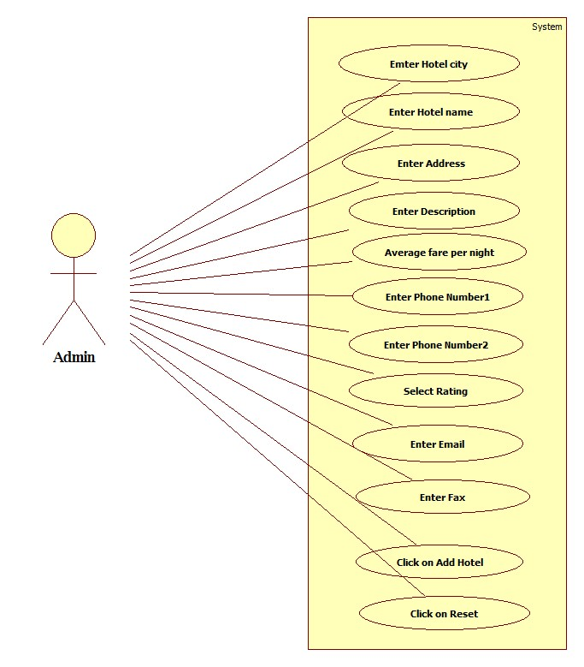

Scenarios

Success Scenarios

* Successful adding of new hotel.
* Successful reset of the data.

Failure Scenarios

* Failed submission of adding hotel due to invalid entry.
* Failed submission of adding hotel due to web server down.
* Failed submission of adding hotel due to database connectivity.
* Failed submission of adding hotel due to network error.

Issues

1. What is to be done if web server is down?
2. What is to be done if there is data connectivity error?
3. What is to be done if data is not getting reset?

UI Specifications

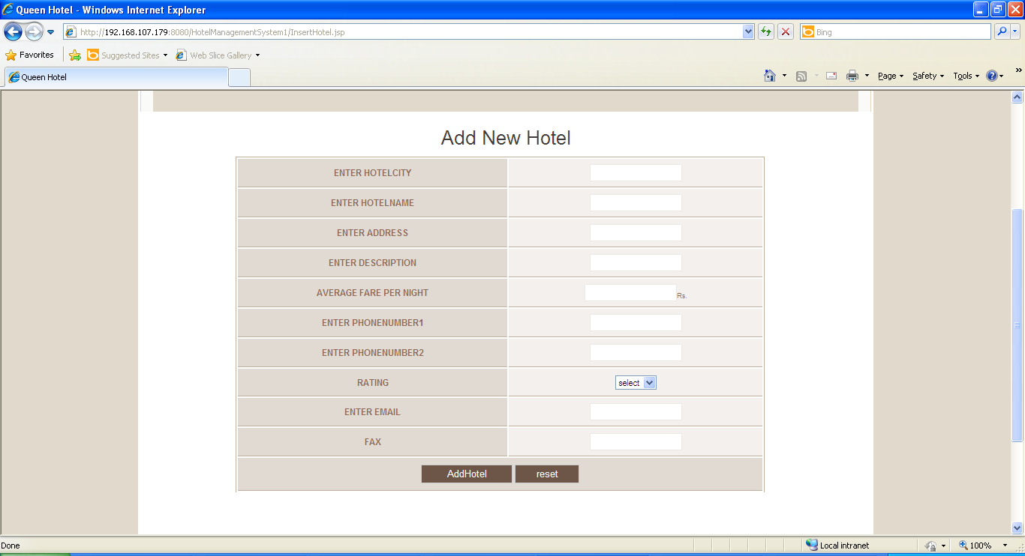

Assumptions

* 1. Only admin can add new hotel.

REVISION HISTORY OF THE WORK PRODUCT

<to be maintained by projects>

|  |  |  |  |  |  |
| --- | --- | --- | --- | --- | --- |
| # | Date | Version # | Section Changed | Details of changes made | Approved By |
| 1 |  |  |  |  |  |
| 2 |  |  |  |  |  |